Citizens are

designers

Supporting people to be designers of local, place-based community action.
A step-by-step guide to joining forces, solving problems and gathering skills and materials to make positive interventions that help the community to flourish.

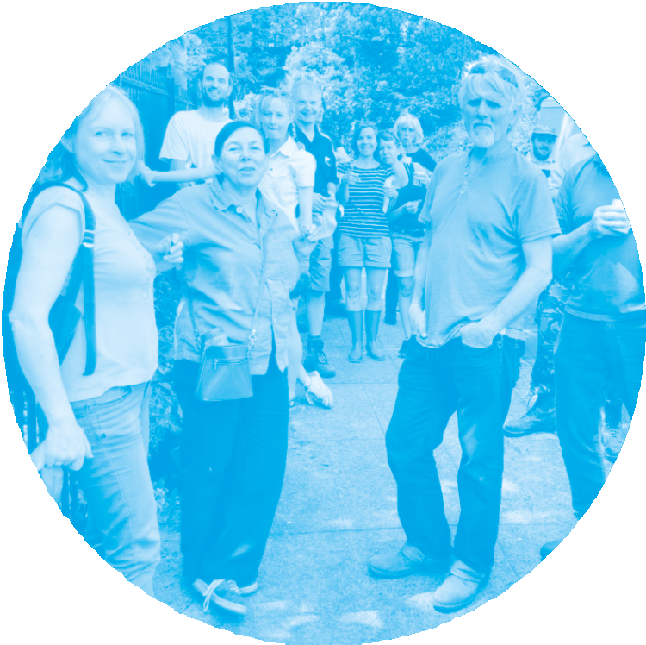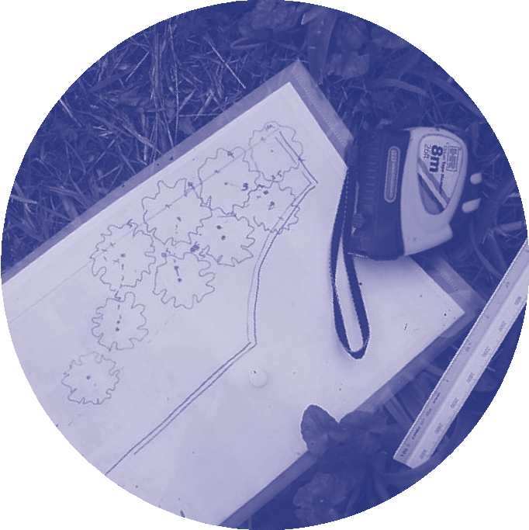

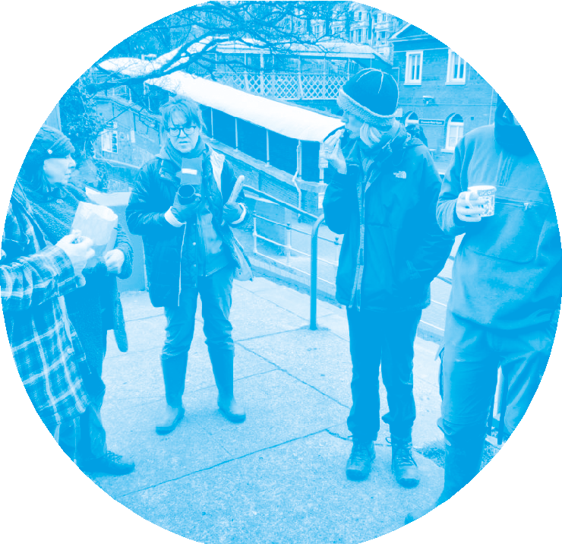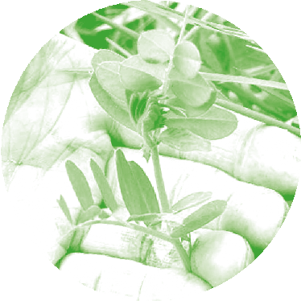Citizens are designers design process

This resource is for everyone and anyone with an interest in getting to know more about their local surroundings and developing ideas to create change.

Take a walk in your neighbourhood, identify an opportunity and do something small, but beautiful for your local surroundings.
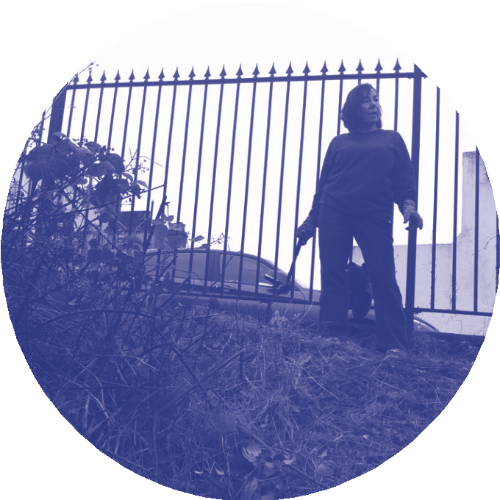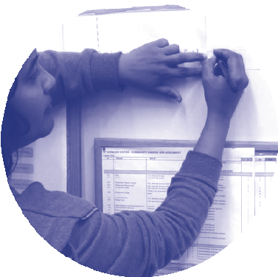

2

Follow this step-by-step process guide or dip in and out as your project evolves. Remember to involve others and keep it enjoyable!

Ask a question
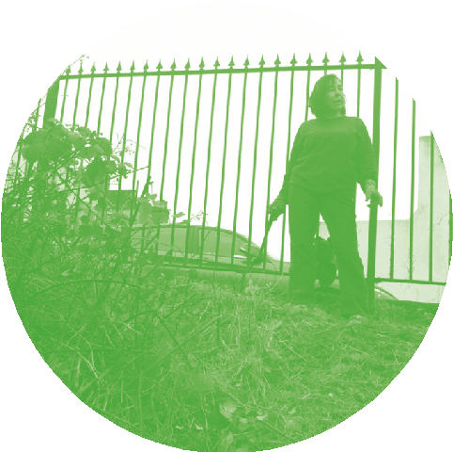Start by asking a motivational question.
Is there a problem you wish to tackle? Are you aware of any needs or opportunities where you live, that might be easily addressed by a small group effort?
For this project we asked “What if we developed an urban forager’s garden in the Bexhill community, to grow free food, increase the biodiversity and beauty of our neighbourhood?”

•
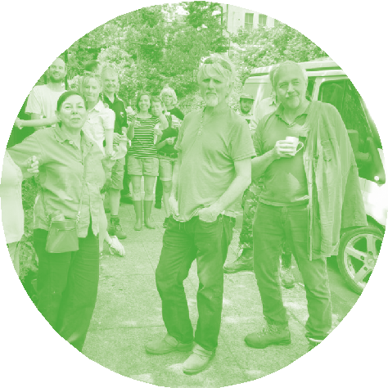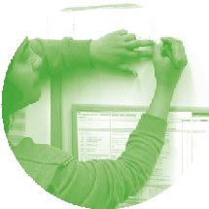Recruit a group
Invite at least one person with a shared interest in your question to join you.

• Prepare your journey
Decide where to go in order to explore your question, look at a map, get ideas from everyone in the group.
Gather your kit – things you will need to record your findings and to enjoy your walk: pens, paper, camera, notebook, tape measure, jars or bags to collect things in, plant finder and compass app, tea and snacks.
For this project we are asking you to plot findings on the Town Tales, Home Stories website https://dlwp.surge.sh/

4

Take a walk
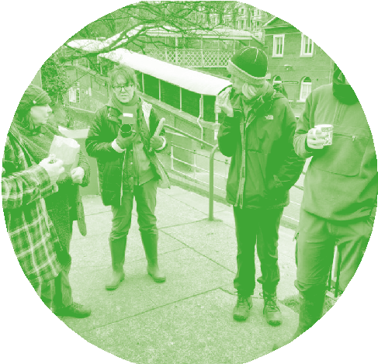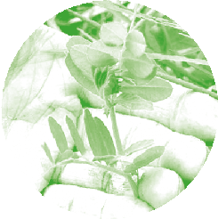Meet up and follow your route. Or you can also let your route emerge as you walk. Take note of what’s around you, look up, down, listen, touch, keeping in mind your question. Ask local residents that you encounter on your journey. Record and gather data as you walk.
For this project we are offering an audio walking guide to support you at soundcloud.com/delawarrpavilion/a-walk-in- search-of-common-land

•
Pause, discuss & create a vision
Stop at sites you think have potential. Can you see an opportunity? Discuss what you’d like to do and assess whether a site is suitable for your needs. Be creative and think about some different approaches.
Discuss ideas and create a shared vision. Who else might you need to consult or work with? Who is likely to benefit from the project?

•
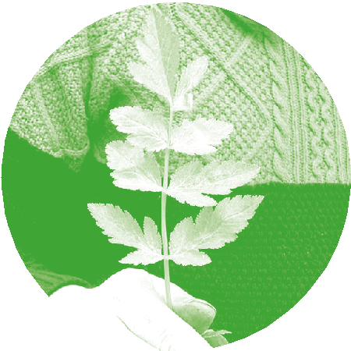Identify skills & resources
Make two lists:
- The skills and resources you already have.
- The skills and resources you think you will need.
What do you need to realise your vision? Include locally available materials, local people and their experience, plants and information such as who owns the land.

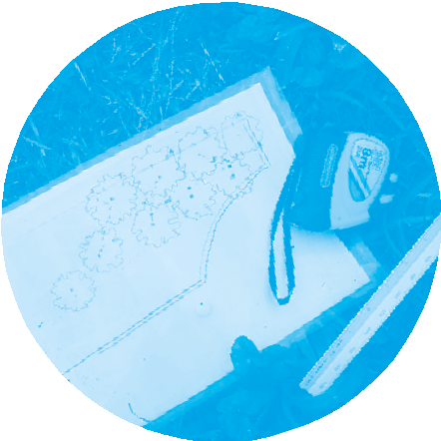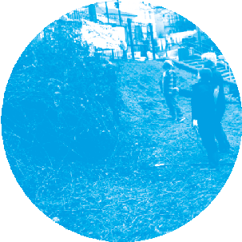Select & map a site
Choose one site to focus on. You may wish to draw sketches, take photos. Use the checklist on page 7 to document your fieldnotes.
Draw a base map on page 8 of this resource
– a quick sketch of the site shape and measurements. Draw your site with rough measurements, a compass direction and include plants and features that you want to keep. For this project we are asking you to plot your ideas on the Town Tales, Home Stories website https://dlwp.surge.sh/

•
Gather skills & resources
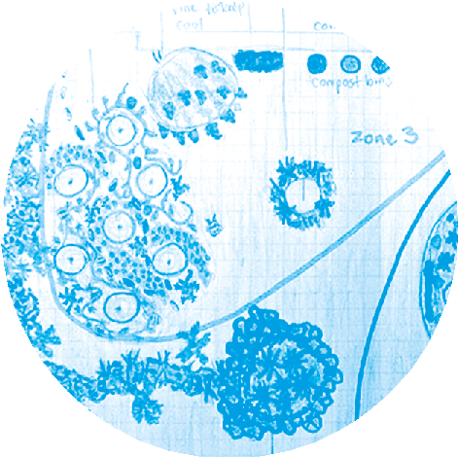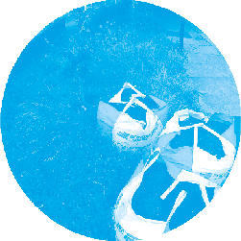Source the skills and resources required, share the task, try to use what you have around you, ask others for skills and resources ideas.

• Design - decide & draw
Decide on your design solution. Draw your
planned intervention to bring your ideas and resources together. See an example plan on page 6.

Develop simple systems
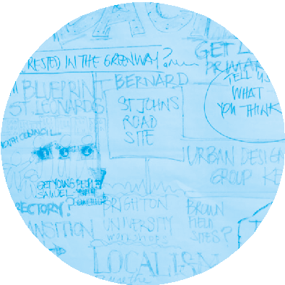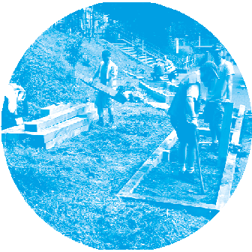Agree what you will do, when will you do it and who will do what. Simple systems help make your design happen, keep the momentum going and ensure the project can be sustained in the long term.

•
Work together
Bring your design to life creatively and resourcefully. Invite others to join in, connect with the community.

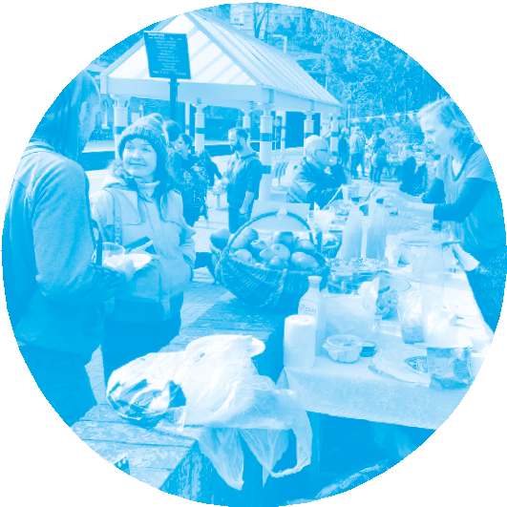• Celebrate & evaluate
Celebrate all that has been achieved,
new connections made and how it has revitalised the community and delivered an easy, place-based solution for your neighbours to enjoy.
Discuss what went well, what didn’t go well, whether there are any next steps or things you would do differently.

•

Share & connect
Share your project and its outcomes with
the wider community. Use local press and social media.

5

Site fieldnotes
Use all your senses: smell, touch, hearing, sight and taste. Get a feel for the space.
Take note of the following aspects:
- Is there easy access to the site?
- Who owns it? If you don’t know make a note to find out later.
- Is there existing vegetation, trees, hedges, shrubs or wild flowers?
- What are the site conditions such as wind exposure, sun, shade and slope?
- Are there signs of people, animals and wildlife?
- Can you spot any potential problems?
- Any useful resources (water, wood etc.)?
- Anything else you notice?

7

Base map
Draw your base map - a quick sketch of the site shape and measurements. Plot a compass on the map.

8

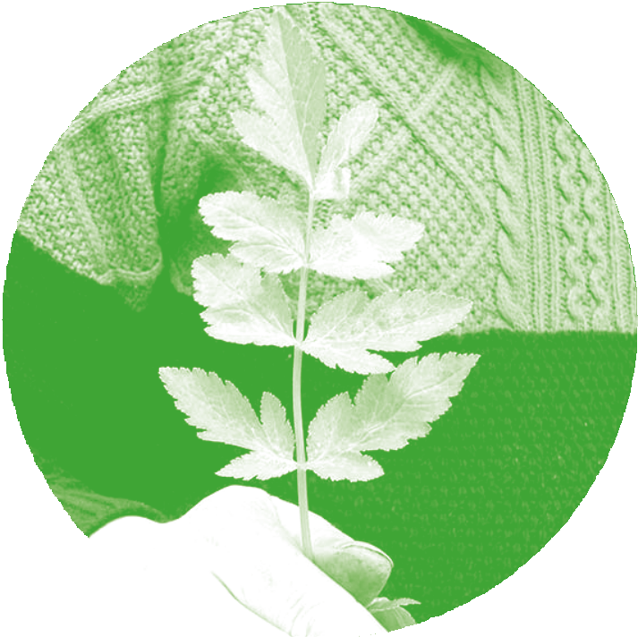This resource was written and designed by Anna Locke and Sarah Macbeth from Transition Town Hastings. All the images are taken at the St Leonards Warrior Square Station community garden.
Citizens Are Designers: In Search Of Our Common Food was commissioned by the De La Warr Pavilion, as part of the Care & Citizenship programme.
Beginning in Spring 2021, Care & Citizenship is a lively series of commissions, online talks, workshops, events and resources co-devised with organisations and individuals committed to creating social change.
Examining varied approaches to care and active citizenship, the programme invites us to find new ways to act with care in our own lives, collaborating with those around us to create a more equitable society.
Care & Citizenship is part of AHRC funded DigiPiCH Civic Museums Project: Using Digital Technology
to enhance Wellbeing in Civic Museums. Partners of the project are De La Warr Pavilion, Bexhill on Sea, The Royal Pavilion and Museums Brighton and
Hove and The Peale Center for Baltimore History and Architecture, Baltimore.
Creative Commons Attribution-NonCommercial- ShareAlike 4.0 International Public License

www.transitiontownhastings.org.uk www.annalockepermaculture.co.uk www.sarahmacbeth.com www.dlwp.com

