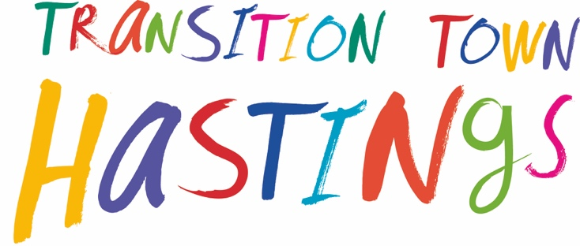

MINUTES
Tuesday, 5th October 2021 / 7.30pm

7.30 pm WELCOME & INTRODUCTIONS
ATTENDEES: Hannah, Sherry, Anna Locke, Anna Sabin, Ursula, Graeme, Sherry, Kate, Linda
APOLOGIES: Philppa, Nick, Kathy

7.40-8.40 pm PROJECTS

Carbon-capture & improving biodiversity
- Community garden & wildflower path (TTH)
  - Next steps for the Path – strimming and planting bulbs
  - Residual budget to be utilised
  - Next sites (Julia’s email re Edmund Road)

Update on Wild about Hastings - Anna Sabin - Andy Philips has been commissioned by HBC to write a Hastings biodiversity report – Maya to present to the council. Verge audits that have been done over the summer. Report will be finished by Xmas. Ready for action in the spring.
Urban tree challenge fund - trees / labour. Looks like funding might come through.
Low Traffic neighbourhoods and Greenway stall - any volunteers?
Linda – November - discussion beforehand. Put Low Traffic Neighbourhoods in the next newsletter.
Use the Eco Hub to highlight things like this that need campaigning on such as local transportation.
Anna and Sherry to fix a date to discuss.

Waste disposal / reducing consumption
Jumble Trail – it was decided to cancel this altogether. Possibly do Christmas at the Common Room instead. Sherry to see if we can change the spec for the event.
- Community composting – next site at the Station? –

UPDATES FROM COMPOST COMMUNITY GROUP
New site - at the Yard funded by Trinity.
Warrior Sq Community Garden - suggest to Paul that we need to use that space bins.
Amanda Jobson – look into possible site at Gensing Gardens.

Community Garden
Encourage people to come to regular gardening slots by offering better refreshments, perhaps cover transport costs etc.
There needs to be a presence to encourage people and it needs to be at a regular time. There needs to be supervision. Things are being planted randomly.
Are there better times for people?
Anna Locke to facilitate a community day for planning the garden. This would help people feel more engaged.
Possibly November for bulb planting?

Next garden meeting 12 October. 4pm at the garden.
There are now parts of the Garden that are Paul - this isn’t a TTH project?
There is too much junk on the site now that people have brought along. Discourage this and let Paul know that the reason is that we will need that space for the Community Compost bins.

Wiggly path
A lot of time and effort - need more people for maintainance.
Path needs to be cut down in the next month. Fergus Garett suggested a planting party. Get a date in the diary. End of November? Invite the home school kids, other kids. Have pizza and social again.

Connecting & sharing
- Green Drinks – Thursday 11 November at Common Room, Eagle House. 7pm B.Y.O.B.
- Community noticeboard – progress update This is under construction. Should be finished next week. Shall we have an opening ceremony?

Climate-change literacy
- Urban density / Ken Davis
- Eco-hub / Green Directory
Suggested that every Thursday the space could be used by different groups, daytime and evening. ESC have a small amount of funding.
Use the back wall to display info on resources / other groups.
Combine groups - Sarah to map projects.
We need a ‘design’ conversation about what it is / who it is for etc. Planning / thinking time to decide a framework around it. What is its purpose as a shared space.
Anna suggested an email / google calendar for groups to use when booking themselves in.
Sherry “ how do we work more collaboratively with limited capacity?”

AOB
Linda: suggested the film “Story of Plastic”. Strandliners to organise a showing.
During the 6 months that we have the Eco hub – have monthly event around different topics:
Plastic / Energy / Waste & packaging / local transport / fashion / food
Or based on the Wellbeing Wheel or the Sustainable development goals.
Organise a drinks event at the Common Room for the various green / eco organisations in town.

- Next meeting date Thursday 4 November 7pm @ Common Room

8.40-9.00pm TTH ORGANISATION AND COMMS

Going forward could Transition Town become the ‘named partner’ for the Garden Town Bid?
This could even be a paid role.

The structure of the Core Group needs thinking about.

Group status
- Governance & sustainability

Finance
- Update on cash situation
- Names on bank account Chris brought documents to sign
- Financial management – developments ?
Sarah has set up an XL spreadsheet [meeting with Chris to refine this]. Purpose: so everyone can have access to see the status of projects and budgets.

AGM
We need an AGM. Proposed date: 13 November at the Common Room. 11am-12pm
Recruit new members – what is the best way to do this? Possibility of a TTH open space before the AGM?

Communications
- Next newsletter - Andrea
- Social media
  - twitter – Sarah
  - FB – Ursula
  - Instagram Garden account - Hannah
- Website development – Sarah

Update pics in Dropbox
Create a social media folder

