**TTH CORE MEETING – 20 May 2025**

**Location: WHITE ROCK HOTEL**

Attendees: Andrea, Farid, Sarah, Sherry, Ursula

Apologies: Anna

Chair: Farid

**ADMIN**

**TRUSTEES INSURANCE**

* All agree to subscribe to a Trustees Insurance
  + Andrea to get a firmer quote and then go ahead
* Wording of the coverage (see p27 of the Ansvar Insurance Policy document):



OTHER INSURANCE ISSUES

* NEW WORDING RE ACTIVITIES COVERED

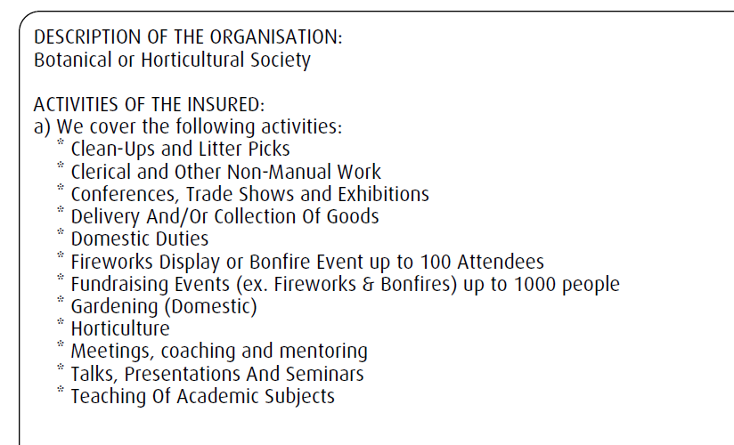

Clarification from the insurance brokers:

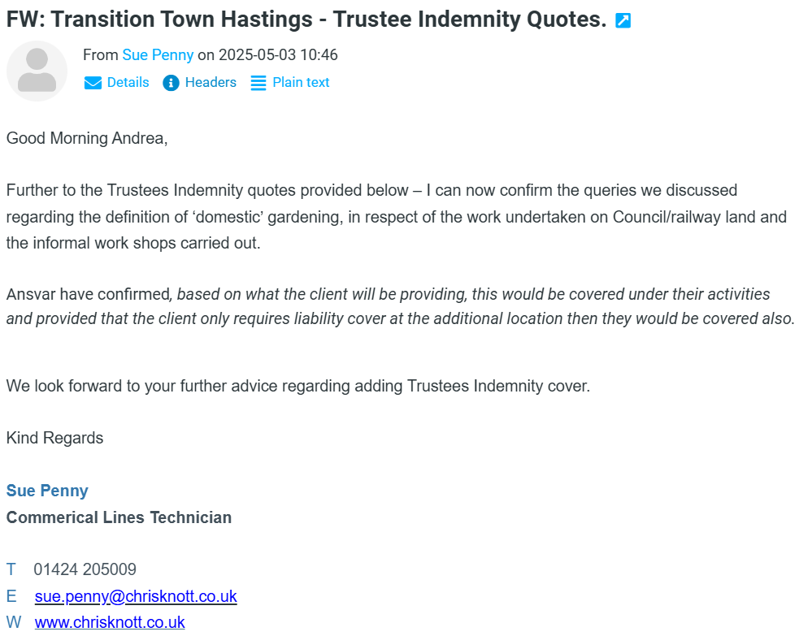

**TTH PROJECTS**

* No update of projects given despite it being on the agenda
* The meeting was taken by the ongoing conversation about the “core” function and identity of TTH with regard to semi-independent projects carried out under its umbrella, whether by current members of the core team, or external parties
* No project is giving proper descriptions and updates on Discord. All projects are strongly encouraged to do that.

**OTHER LOCAL PROJECTS**

**LINTEN GARDENS**

* Local community group wanting to grow dwarf fruit trees and soft fruit bushes on community space, requesting to be covered by TTH insurance
* They aim to apply for small grants from HVA and Trinity
* Ursula to suggest that Sarah Gomes ask Lucy Abbot for coverage

**HVA SMALL GRANTS PROGRAMME**

* Including PL Insurance for small local groups
* A 10k for collective impact pot

**NEXT MEETING**: TBD